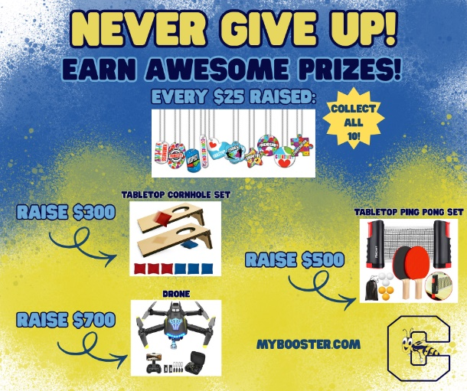

Our Conley Yellowjackets Pace Setters FUNdraiser is in full swing! Make sure you get your student registered at MYBOOSTER.COM so they can earn their first prize - our Conley Yellowjackets - Never Give Up bracelet! Students can raise money for some fun prizes for themselves as well as help our class earn some awesome fun days and parties.
